UPSC Pods: Content Building Plan
Oct 10, 2026 · @Edureka

Summary
UPSC Pods content is text first, with motion, music and illustration as seasoning that adds under 1.5 MB to the app and about 40 KB to a day's data. Every piece is made once, from one source file, and comes out three ways: as an in-app piece, a share card, and a short video for Reels and Shorts.
The mood is a chai stall at 7 am, not a coaching hall: warm brown and teal, hand-drawn everyday objects, soft Indian acoustic sound, and slow, small movement. It should feel like a friend sitting next to you, never like an ad shouting at you.
Three rules hold for every piece:
- It works with everything off. With sound muted, animations off, data saver on and font at 200%, the piece still teaches the same thing.
- The mood follows the user, never the reverse. No countdowns, streaks, confetti, scare stats or hype. Heavy news and result days get quieter, not louder.
- Nothing private is ever shareable. Pod chat, Close the Day, mood and attempt number never appear in a share card. Tragic cards have no share button.

Who it is for, and what limits it
The content is made for Arjun and Kavya first: Hindi-medium, on a phone under ₹12k, on patchy mobile data, often studying alone late at night. If it works for them, it works for Meera.
Constraint | What it means for content
Hindi-medium majority | Every piece ships in Hindi and English at the same time, each written natively, never translated word for word. Hindi voiceover is recorded first, not as an afterthought.
Low-end phones (2-4 GB RAM) | Motion is vector, drawn by the phone, never video. Scenes stay under 30 layers and must hold 60 fps on the slowest test phone.
Patchy data, about 150 KB a day | Text arrives first and works alone. Illustrations, sound and explainers are separate packs that download overnight on Wi-Fi. Data saver means text only.
APK already 65 MB | Content adds at most 1.5 MB to the app. Everything else is downloaded and can be deleted from a storage screen.
Late-night lows (around 23:30) | After 20:00 colours dim, motion slows, and no new sound plays unless the user starts it. Close the Day stays quiet.
Distrust of hype | No topper faces, no rank claims, no "last chance", no countdowns or streaks. Humour comes from shared aspirant life, never from someone's failure.
Accessibility | Captions on every video, a transcript for every voiceover, alt text for every illustration, and full support for the system setting that removes animations.

Content formats
Eight formats cover the brief's emotions, from fear of writing to late-night loneliness. Each one has a fixed template, so a small team can make it every week.
Format | What it is | Emotion it meets | Rich layer | Cadence
Chai Cards, illustrated | Today's 5 news cards, each with one small vector illustration and a 300 ms entry | Overwhelm | One illustration per card (8 KB or less), tone-tagged colour | 5 a day
Ek Minute explainers | 45-60 s motion explainers of one static concept (Art. 200, El Niño, GI tags), played by tap | Fear of the syllabus | Vector scene, Hindi and English voiceover, captions, soft music bed | 3 a week
Map and timeline stories | Tap a state, drag along a timeline, see what changed (rivers, Modern History, schemes by region) | Information overload | Interactive vector India map, small tap sounds | 1 a week
Study soundscapes | Original 3-minute seamless loops for focus: Chai stall morning, Monsoon desk, Night library, Rooftop at dusk | Loneliness | Indian acoustic instruments (tanpura, santoor, rain, distant traffic) | 1 a month
Practice games | Guess the PYQ, Drop the pin on the map, Match the Article. Low stakes, no scores shown to others | Fear of failing | Light motion, short sound effects, a calm "try again" | 1 new pack a week
Quiz night packs | A 15-question Friday pack a pod lead runs in Rooms | Fun, belonging | Reveal animations, a shared sound cue | Weekly
Repeater stories | 2-4 minute audio stories from repeaters, alumni and Plan B members, with 3-4 still illustrations | Shame, desperation | Recorded voice, gentle score, illustrated stills, no faces unless they ask | 1 a week
Honest Guide visuals | Result cards for the attempts and cost-of-a-year calculators, 5-source maps, the parent page | Greed, family pressure | Clean infographic templates in both languages | Built once, refreshed each cycle
Two things are left out on purpose: long video lectures (coaching apps do these, and they are heavy on data), and anything that ranks people.

Look, sound and motion
The look, sound and motion all follow one mood system: each piece's tone tag (already on every Chai card) and the time of day set how much colour, movement and sound it gets.
Tone tag | Colour | Motion | Sound | Humour
LIGHT | Full chai brown #8D4F01 with marigold accents | 300 ms entry, one playful beat allowed | Music bed allowed | One Chotu joke if it carries the fact
NEUTRAL | Brown and teal #14696B | 200 ms fade and rise | Music bed allowed | None
SERIOUS | Teal and greys | 150 ms fade only | Voice only, no music | None
TRAGIC | Greys on the surface colour, no accent | None: the card simply appears | Silent, no voiceover | None, no emoji, no share button
After 20:00 | Dark theme, warmer and dimmer | Halved, nothing new starts on its own | Only what the user starts | Unchanged
Result-day mode (72 hours) | Surface colour only | None | Silent | None
Illustration. Flat, two-tone line art with a slight hand-drawn wobble, built from the app's own palette. The subjects are everyday aspirant life: a kulhad of chai, a library desk with a ceiling fan, a steel tiffin, Mukherjee Nagar rooftops, a phone torch during a power cut. People are drawn without fixed faces, and include women, small-town and older aspirants. A kit of about 60 reusable parts (objects, hands, backgrounds, map pieces) lets one designer make a card illustration in about 20 minutes.
Type. Martel for all reading text, the system sans for interface text, at the sizes the UI guide set (17 sp reading, 1.6x line height for Devanagari). Text in motion pieces stays on screen at least 2 seconds per line, and nothing important sits only inside an animation.
Motion. Small, slow and purposeful, following the UI guide: 150-300 ms, standard easing, no confetti, shimmer or looping. Explainers are the one place motion runs longer, and only after a tap, with pause and replay controls. When the phone's "remove animations" setting is on, every piece shows its key frame as a still image with the same text.
Sound. Off by default, never autoplays, and is switched on per format in settings. The palette is Indian acoustic: tanpura drones, santoor and sitar plucks, tabla played softly, rain, ceiling fans and distant chai-stall noise. A three-note "chai motif" (a santoor phrase about 1.5 seconds long) is the sonic logo, opening on a soft chai-pour sound; it ends every explainer and reel but never plays as a notification. All audio is mastered to the same level (-16 LUFS) so nothing jumps out at night. Music is commissioned from an independent composer with full rights bought out, so it can be used in the app and on YouTube and Instagram without claims.
Voice. Two regular narrators, one Hindi and one English, sound like a senior friend: unhurried, warm, never a news anchor. Chotu has no voice for now, since the UI guide keeps it clearly labelled as AI and quiet by default.

How it plugs into the app
Every format lands in a screen the build thread has already made, so no new tab is needed. This plan doesn't change the app's code; the table is the hand-off for the build thread.
Screen | What content adds | How it fits what is built
Onboarding tour | The 3 tour screens become short motion scenes: a Chai card arriving, a pod saying hello, a day closing | Same screens and copy, one vector scene each, skippable as now
Today | Each Chai card gets its illustration in the headline zone; the "That's today's Chai" end screen gets a still kulhad drawing | Illustration sits above zone 2 and is the first thing dropped in data saver. The 6 zones and trust footer stay as they are
Chai card, "Explain simpler" | When an Ek Minute explainer exists for the card's static concept, a "Watch 1 min" chip appears beside Chotu's answer | Uses the card's existing static-link chip to find the explainer. Hidden on TRAGIC cards, like the button itself
Practice | Chai archive gains the explainer library, map and timeline stories, and the weekly game packs | Each opens from the archive list; game results stay on the phone and feed the existing day 3, 10 and 30 revision
Pod | Weekly Wins card templates, quiz-night packs for pod leads, and a small sticker set for chai pings | Wins cards are opt-in and show no ranks, matching the pod strip's presence-not-performance rule
Rooms | Soundscapes play in study rooms, chosen by the room host; quiz night runs here on Fridays | Sound plays only on each person's own phone, and anyone can mute it
Chotu | No new content inside the chat. Chotu can point to an explainer or story by name when asked | Chotu still never responds to distress, and nothing here changes its rules
My Path | Calculator result cards, the parent page, and Repeater and Plan B stories | Stories sit under Plan B; the calculator cards gain a share button
Close the Day | An optional 60-second wind-down sound (tanpura and rain) the user can start before writing | The closing line "Day closed. You showed up. That counts." stays alone on its screen, still and silent
News desk | Each editor-approved note gets an illustration slot and a "needs explainer" flag | Editors approve the illustration and voiceover script along with the text, English and Hindi separately
Technical shape, for the build thread to confirm. Content arrives as packs: a small JSON manifest that lists each item, its language, tone tag, size and sources, plus its files. Illustrations are vector drawables; explainers are Lottie scene files (a single new library); audio is Opus with an AAC fallback, played through the platform media player. A storage screen in My Path lists each pack, its size and a delete button.

Size budget and offline use
Content adds at most 1.5 MB to the APK and keeps a normal day at about 80 KB of data, well under the 150 KB the UI guide set. Sizes below are planning estimates from typical file sizes; the first packs should be measured against them.
Item | Where it lives | Size (estimate) | When it downloads
Illustration kit, UI sounds, India base map, 1 soundscape, Lottie library | Inside the APK | 1.5 MB or less in total | With the app
Daily Chai pack: 5 cards of text | Downloaded | 40 KB or less (already set) | Overnight on Wi-Fi, or text-only by 06:30 on mobile data
Daily illustrations: 5 vector drawings | Downloaded | 40 KB or less (8 KB each) | With the daily pack; skipped in data saver
Ek Minute explainer | Downloaded | About 60 KB scene + 120 KB voice per language | Weekly pack, Wi-Fi only, or on tap
Map or timeline story | Downloaded | 30-80 KB | Weekly pack
Soundscape (3-minute loop) | Downloaded | About 720 KB at 32 kbps | Only when the user picks it
Repeater story (3 minutes of voice) | Downloaded | About 360 KB | Only when the user taps play; streams if they choose
- Text always works alone. If no pack has arrived, every screen still shows its text, and nothing waits on the network.
- Users control storage. Packs older than 30 days are cleared automatically, except anything saved for revision. The storage screen shows totals and lets the user delete any pack.
- No video inside the app. Explainers are drawn on the phone from small scene files. MP4 versions exist only for social media.
- Note for the build thread, not changed here: most of the 65 MB is the on-device AI runtime. Moving it to an on-demand download would bring the install near the 12 MB target the UI guide set, which matters for downloads from Reels links on mobile data.

Production pipeline
Nothing reaches the app or social media until an editor approves it, and the same approval covers all three outputs.
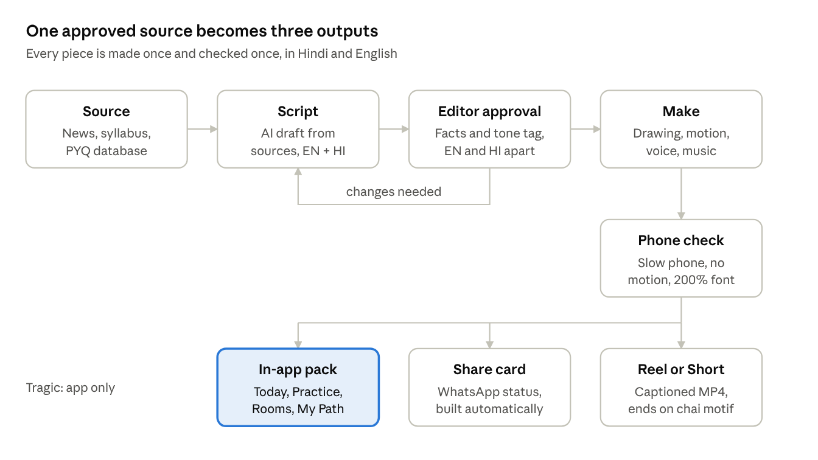
production pipeline · 5 steps, 3 outputs
An editor can send any script back before anything is drawn, which keeps fixes cheap. Pieces tagged TRAGIC stop at the in-app pack and are never turned into share cards or reels.
Role | Does | Load
Content lead | Picks topics, owns the calendar and the tone rules | Full time
English editor and Hindi editor | Approve facts, tone tag and scripts, separately, as the news desk already does | Full time each
Illustrator and motion designer | Card drawings from the kit, explainer scenes, share templates | 1 full time, a second from month 3
Composer and sound designer | Soundscapes, music beds, the chai motif, mixing | Commissioned per pack
Hindi and English narrators | Explainer and story voiceover | Per session, about 2 hours a week each
Story producer | Finds and records Repeater stories, gets written consent | Part time
Wellbeing reviewer | Checks every story and heavy topic before it goes out | A few hours a week
Tools. Figma for illustration and templates, After Effects with the Lottie exporter for explainer scenes, Reaper or Audacity for sound. Scripts are drafted by AI only from attached source text, the same rule the Chai cards follow. Every template is built in Hindi and English, so Devanagari line breaks are tested from day one.

Content as marketing
The marketing plan gets its creative from the app itself: every share card and reel is a real in-app piece, and each one deep-links back to that same piece so a new user lands on something useful, not a sign-up wall. These formats and cadences were sent to the marketing plan thread so both plans use the same list.
In-app piece | Share version | Where it goes | Rule
Chai card | "Chai of the Day" status card, 1080×1920, in the reader's language | WhatsApp status, Telegram channels | One-tap share from the card; never on TRAGIC cards
Today's 5 Chai cards | "Chai in 60 seconds": a daily vertical video built from the day's card illustrations with one narrator, in Hindi and English | YouTube Shorts, Instagram Reels, Moj | Built from a fixed template the same morning; TRAGIC cards are left out
Ek Minute explainer | Captioned 45-60 s MP4 in Hindi and English, ending on the chai motif | Instagram Reels, YouTube Shorts, Moj and Josh | The fact must stand on its own, with no "download to see more"
Honest Guide data | "Honest odds" explainers: what published UPSC numbers say about attempts, cutoffs and Plan B | Reels, Shorts, the Honest Guide | Public, sourced cohort numbers only; never a personal prediction, and Chotu never gives odds
Study soundscape | 1-3 hour "study with me" video with the illustrated scene | YouTube, and audio platforms if the composer contract allows | Calm on screen, with no timer and no countdown
Quiz night pack | 5-question carousel or poll with the answer next day | Instagram, Telegram polls | Answers link to the explainer in the app
Weekly rhythm dots | A card of the member's own 7 dots for the week, with no count or streak number | Member's own status, if they choose | Opt-in each time; the rhythm stays private otherwise
Wins card | Wins of the week, a plain, warm card ("First full mock written") | Member's own status, if they choose | Opt-in each time, no ranks, no scores, no attempt number
Calculator result | Attempts and age, or cost of a year, card | Member's own status, parent WhatsApp | Shows only what the member picks to show
Repeater stories | 60-90 s audio clip over the stills, with full captions; a monthly pick goes out on social | Reels, Shorts, a podcast feed | Written consent, a wellbeing review, no result claims
Result-window "waiting room" | Calm cards and soundscapes for the days before Mains 2026 and Prelims 2027 results; a "Restart" series after | App, Telegram, Instagram | Restart starts only after the 72-hour result-day quiet period; nothing aimed at non-qualifiers in those 72 hours
Parent page | One-page image in Hindi and English | Family WhatsApp groups | Calm and factual; it never asks parents to push
- Never shareable: pod chat, Close the Day, mood, attempt number, anything from Rooms, and any card from result-day mode.
- Brand mark: a small "UPSC Pods" mark and the chai motif. No discount codes or download pressure on organic content.
- Attribution: each share link carries the piece's id, so the team can see which pieces bring installs (the metrics section covers this).

Calendar and rollout
The rollout front-loads explainers so 30 are ready when the Prelims notification lands on 13 January 2027 (the date in the founding brief), the moment the most aspirants are searching.
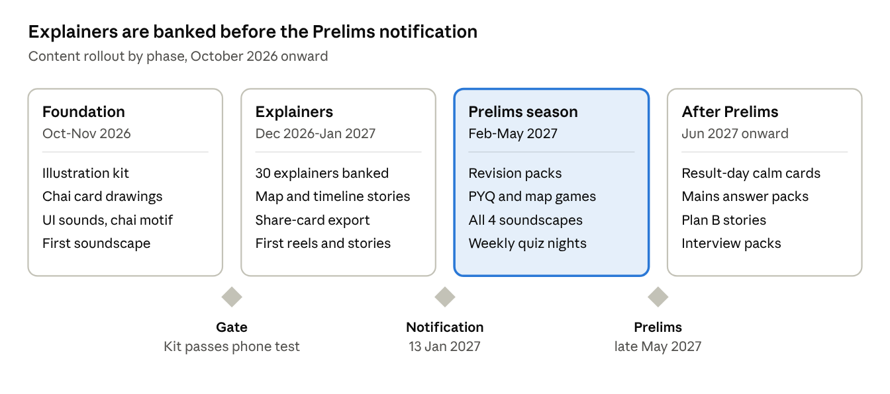
content rollout · 4 phases, 3 gates
The weekly rhythm follows the brief's community week: Chai cards every morning, explainers on Monday, Wednesday and Saturday, the map or timeline story on Tuesday, a quiz-night pack for Friday, and a Repeater story on Sunday alongside Wins of the week. The Prelims date in the drawing is approximate; use the official notification.

Measuring what works
Content is judged by whether it helps someone learn and come back calmly, so the app's main measure stays days closed per user per week (target 3 or more). Time in app and streaks are not tracked as goals.
Measure | Target to start with | What it tells us
Chai stacks finished | 60% or more (from the UI guide) | Whether illustrations help or slow people down
Explainers watched to the end | 70% or more | Whether 60 seconds is the right length
"Watch 1 min" taps after "Explain simpler" | Watch the trend | Whether explainers answer real confusion
Saved for revision, per 100 cards | Watch the trend | Which formats people want to keep
"Spot a mistake" reports per 100 pieces | Under 1, and every report fixed within a day | Fact quality
Data per day, median user | 150 KB or less | Whether packs stay light
Installs per share link, by piece | Rank pieces monthly | Which content earns downloads, shared with the marketing thread
Sound and motion switched on or off | Track only | How many people use the rich layer, and whether text-only users finish as often
Each month the content lead reviews the top 10 and bottom 10 pieces in both languages and changes templates, not people's habits.

Risks and open decisions
Risk | What to do
A wrong fact in a reel spreads faster than a correction | Same editor approval as Chai cards; a pinned correction on the post and a fix in the app within a day
Music copyright claims on YouTube or Instagram | Commission original music with a written buy-out of rights; no film songs or trending audio
Hindi feels translated | Hindi scripts written first by the Hindi editor for half the pieces, and a Hindi-medium aspirant reviews every template
Motion stutters on cheap phones | Test every template on the slowest test phone before use; cap scene layers
One designer becomes a bottleneck | The 60-part illustration kit and fixed templates; a second designer from month 3
Stories cause harm to the teller or listener | Written consent, the right to withdraw, wellbeing review, helpline line at the end of heavy stories
Decisions for you:
- ☐ Close the Day wind-down: allow the optional 60-second sound, or keep that screen fully silent? Recommended: allow it, user-started only.
- ☐ Chotu's name: the UI guide asked for a test with about 10 users before it goes into marketing. Recommended: run it before the first reels.
- ☐ Lottie as the one new library for explainers, or draw explainers in Compose with no library? Recommended: Lottie, as the team can then use After Effects.

